Title

Author 1 [First Name Surname], Author 2 [First Name Surname]
Institution 1, Institution 2
E-mail 1, E-mail 2
Abstract
Each paper must include an abstract of max. 200 words, written in English.
Keywords: Keyword 1, Keyword 2, Keyword 3, Keyword 4

Heading 1
When preparing the paper, it is recommended to write directly into this document template and to replace the model text. The basic structure of each text consists of the title, author(s), institution, e-mail, abstract, keywords, structured main text, references. Do not insert blank lines between sections or paragraphs.

1.1. Heading 2
Full papers should have a minimum of 6 and a maximum of 10 pages including references, tables, and figures. Poster papers should have a minimum of 4 and a maximum of 6 pages including references, tables, and figures. Each paper should be submitted both as a doc/docx file and a PDF file.

1.1.1 Heading 3
In-line references should be given in brackets as follows (Brown 2011, p. 56). Long quotations (three lines or more) should be presented in a separate paragraph
Long quote. (Brown 2011, pp. 56-57)
Examples should be presented as follows.
(1) a. All examples must be numbered consecutively throughout the paper.
b. Sub-example
(2) Example
Lists can be presented either in the form of a numbered list or a hyphened list.
- Numbered list
- Hyphened list
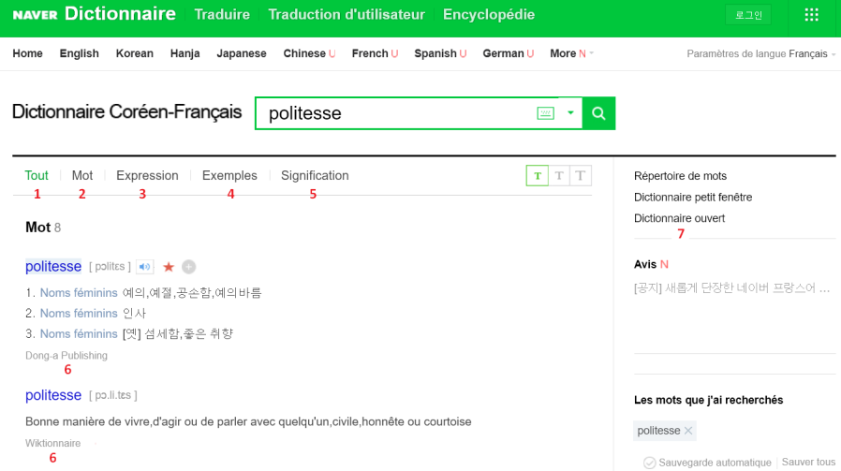
Figure 1. Caption
Figures should be high-resolution.
 | Declarative | Interrogative | Imperative | Exhortative
Formal style | -(su)pnita | -(su)pnikka | -(u)sipsio | -(u)sipsita
Polite style | -a/eyo
Semiformal style | -o/so |  | -o | -psita
Familiar style | -ney | -na/-nunka | -key | -sey
Intimate style | -a/e
Plain style | -ta | -(nu)nya | -(e)la | -ca
Table 1. Caption
Tables and figures should be numbered separately.

References
All bibliographical references used in the text should be listed in the alphabetical order of the (first) author’s family name and online sources should indicate the last access in brackets.
Brown, L. (2011) Korean Honorifics and Politeness in Second Language Learning. Amsterdam: John Benjamins Publishing Company. [BOOK]
Culpeper, J. (2011) Politeness and impoliteness. In K. Aijmer, G. Andersen (eds.) Sociopragmatics, Volume 5 of Handbooks of Pragmatics edited by Wolfram Bublitz, Andreas H. Jucker and Klaus P. Schneider. Berlin: Mouton de Gruyter, pp. 391-436. [BOOK CHAPTER]
Choi, J. (2016) Aperçu historique du dictionnaire bilingue en Corée: Le cas des dictionnaires français-coréen et coréen-français. In International Journal of Lexicography, 29(2), pp. 184-199. [JOURNAL PAPER]
Jeon, H-Y. (2004) Hankuke kongsonphyohyenuy uymi (On the meaning of polite expressions in Korean). In hankuke uymihak, 15, pp. 71-91. [NON-LATIN SCRIPT CONTRIBUTION: transcription and translation in brackets]
Jung, H.-Y. (2015) Forms of address in French-Korean and Korean-French dictionaries from the perspective of a French learner of Korean. In Proceedings of Asialex 2015, Words, Dictionaries and Corpora: Innovation in reference science, 25-27 June 2015. The Hong Kong Polytechnic University, Hong-Kong. [CONFERENCE PAPER]
Kim, Y.-S. (1997) Contacts des langues et des cultures: Les emprunts du coréen au français examinés à partir du Dictionnaire Coréen Essentiel de H.-S. Lee. Phd Thesis. Besançon. [PHD THESIS]
Urimalsaem. (2016) https://opendict.korean.go.kr/main. (last access: 10.03.23) [WEBSITE]

Acknowledgements
If applicable.

Footnote.

